Normal / Gaussian Distribution:

Definition: In probability theory and statistics, normal or Gaussian distribution is a type of continuous probability distribution for real-valued random variable.

Example: Heights / Weights of student in a class

Example: IRIS Dataset -> Petal length, Petal width, Sepal length, Sepal Width

This dataset also follows normal distribution

Probability density function will be used.

Bell curve usually.

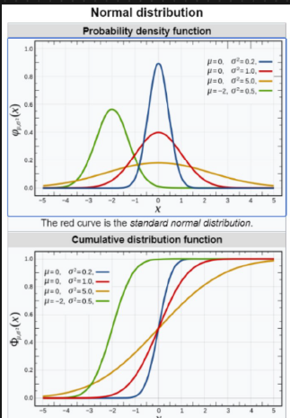

As the variance increases, the spread of the data increases.

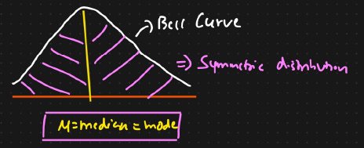

Mean = Median = Mode

Bell curve is a symmetric distribution

Notation: N(μ, σ²)

Parameters:

μ $ϵ$ R = mean

**σ² $ϵ$**  R > 0 = variance

x $ϵ$ R = random variable

PDF = $\frac{1}{σ\sqrt{2π}}$ $e^{\frac{-1}{2}}$ ${( \frac{xi-μ}{σ})}^{2}$

* *

Mean of normal or Gaussian distribution:

μ = $\frac{\sum_{i=1}^{n}{xi}}{n}$

Variance:

**σ²** = $\frac{\sum_{i=1}^{n}{{(xi-μ)}^{2}}}{n}$

$σ$ = $\sqrt{variance}$

Empirical Rule of normal / Gaussian distribution:

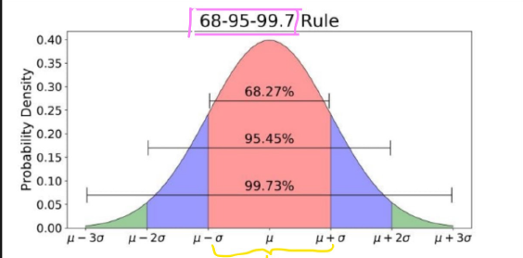

Suppose we have a random variable x that follows a normal / Gaussian distribution

If a random variable follows Gaussian distribution, then we make some assumptions related to probability

Pr(μ – σ $≤x ≤ μ+ σ$) = 68% approx.

Pr(μ – 2σ $≤x ≤ μ+ 2σ$) = 95% approx.

Pr(μ – 3σ $≤x ≤ μ+ 3σ$) = 99.7% approx.

68% of the distribution fall within the first standard deviation

95% of the distribution fall within the area between two standard deviation

99.7% of the distribution fall within the area between three standard deviation